**BITS-PILANI – DUBAI, Dubai International Academic City, Dubai, UAE**

**Course Title : Computer Networks**

**Tutorial-10**

1. Find the shortest distance from A to H on the network below using Dijkstra’s Algorithm



1. Find the routing table available at node A1 for the case of both the hierarchical and non-hierarchical routing.

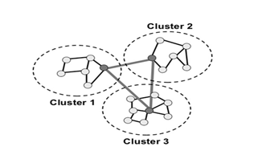

1. Draw the schematic diagram for flooding in a given network with TTL=3. (A to G)

